SIMATS ENGINEERING
ASSESSMENT TOOL 2

COURSE NAME: CSA07 COURSE CODE: Computer Networks

COURSE OUTCOME COVERED

CO1: Apply the functions of OSI layer in enabling reliable data transmission across networks. (BL2, BL3)

Assessment Tool Weightage: 30%

Annexure A

CONCEPT MAPPING

1. A partially completed concept map is given below:
Application → Presentation → ______ → Transport → Network → ______ → Physical.
Analyze the missing layers and explain how their functions are essential for reliable communication.

SOLUTION:

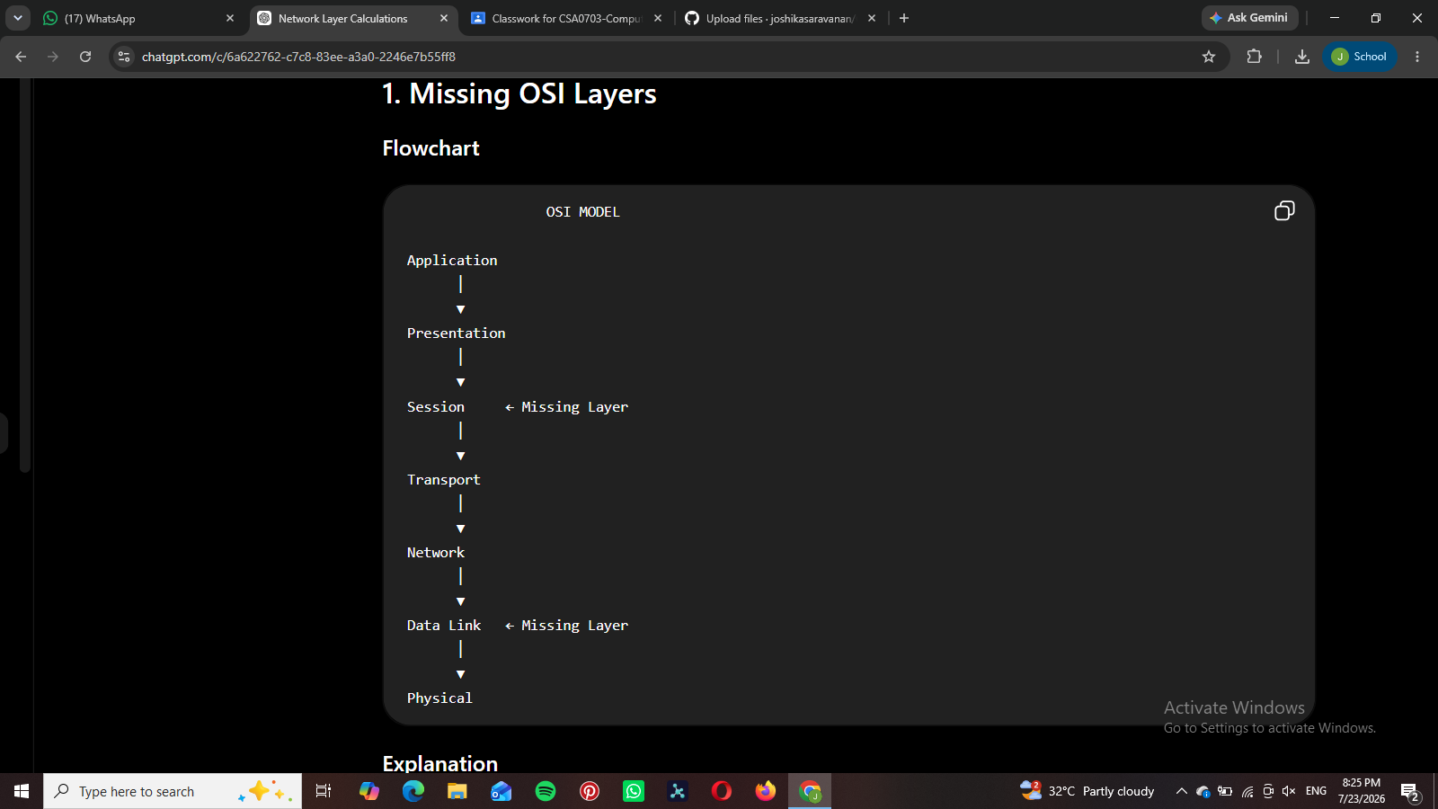
- Session Layer: Establishes, manages, and terminates communication sessions.

- Data Link Layer: Provides framing, MAC addressing, and error detection for reliable node-to-node communication.

2.Construct a concept map linking data units (Segment, Packet, Frame, Bits) with their respective OSI layers and analyze how transformation of data units supports transmission.

SOLUTION:

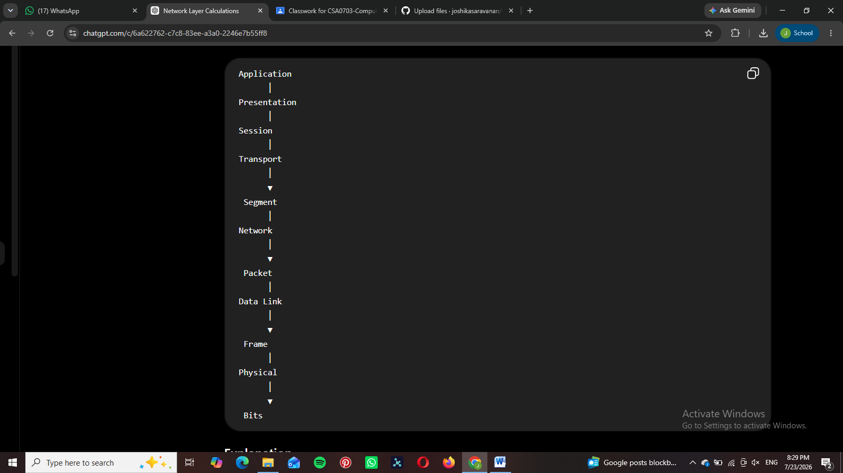
- Transport Layer → Segment
- Network Layer → Packet
- Data Link Layer → Frame
- Physical Layer → Bits
Each layer converts the data into a suitable format for transmission.

3.Given the concept map:
DataLink→MACAddress→LocalDelivery
Network → IP Address → Global Delivery
Explain how these relationships ensure complete data delivery across networks.

SOLUTION:

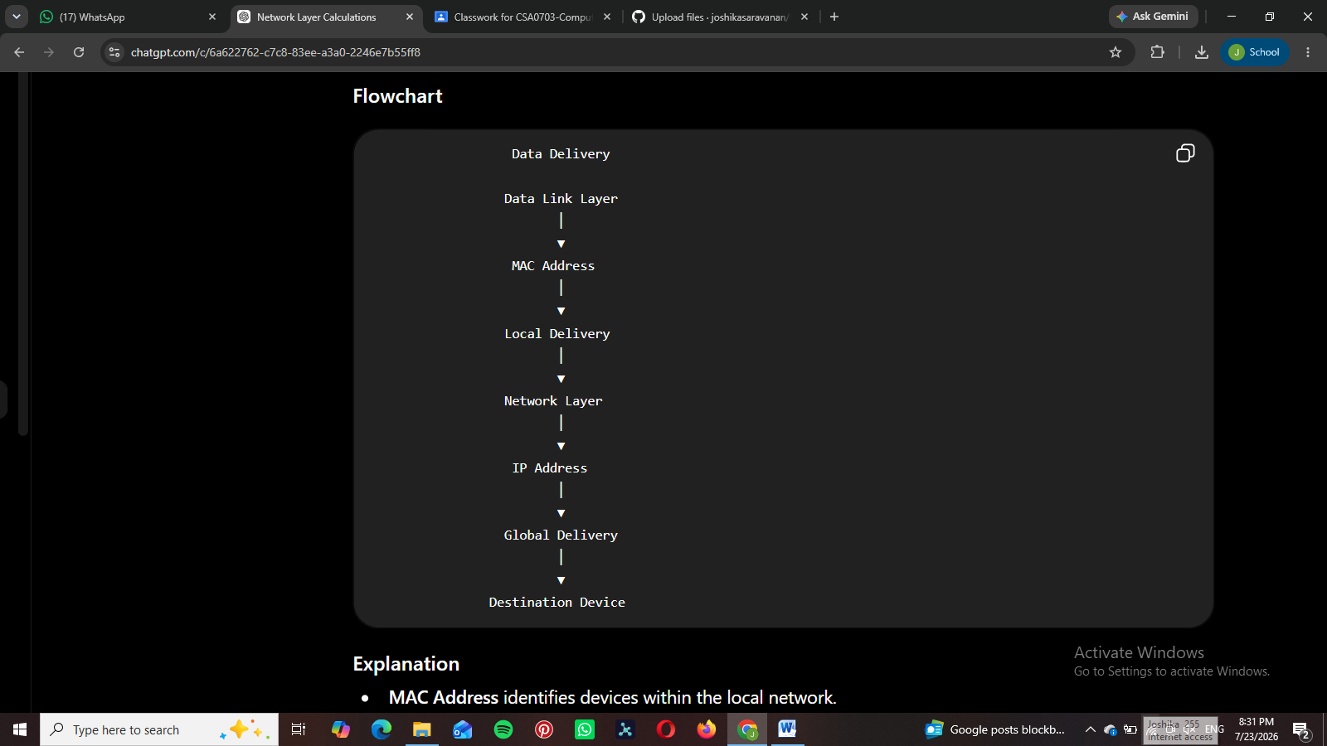
• MAC Address identifies devices within the local network.
• IP Address identifies devices across different networks.
• Together they ensure complete end-to-end communication.

4. A concept map shows:
ErrorControl
→DataLinkLayer→ErrorDetection
→ Transport Layer → Error Correction
Analyze how the interaction between these layers improves reliability in data transmission.

SOLUTION:

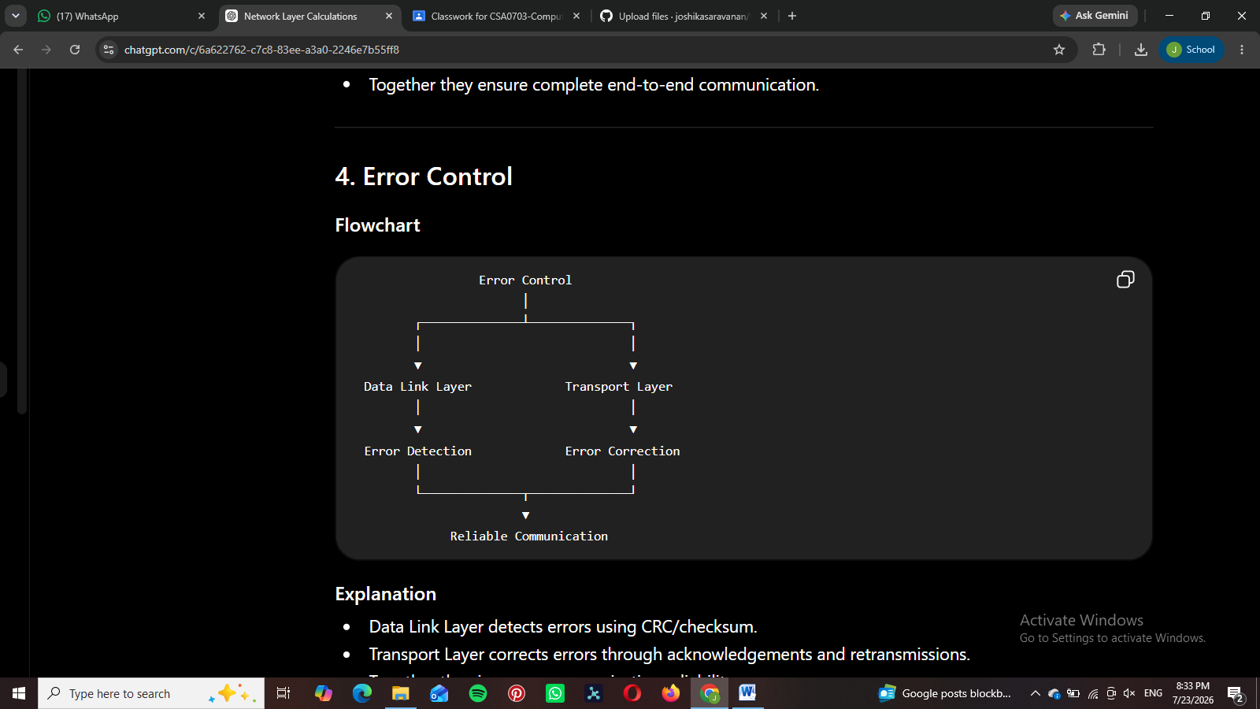
• Data Link Layer detects errors using CRC/checksum.
• Transport Layer corrects errors through acknowledgements and retransmissions.
• Together they improve communication reliability.

5. Develop a concept map for web browsing using OSI layers and analyze how failure in one layer affects the entire communication process.

SOLUTION:

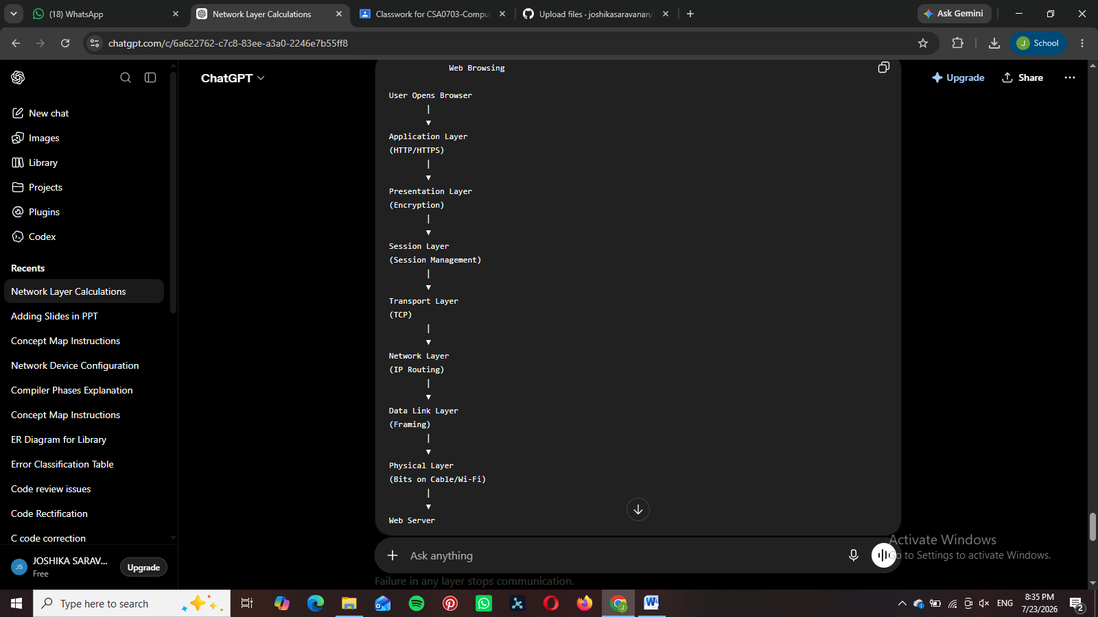
Failure in any layer stops communication.
- Physical failure → No signal.
- Network failure → Cannot reach destination.
- Transport failure → Data loss.
- Application failure → Web page cannot load.

6. A network issue is represented in the concept map:
Physical ✔ → Data Link ✔ → Network ✖ → Transport ✖ → Application ✖
Analyze the problem and explain how the concept map helps in troubleshooting.

SOLUTION:

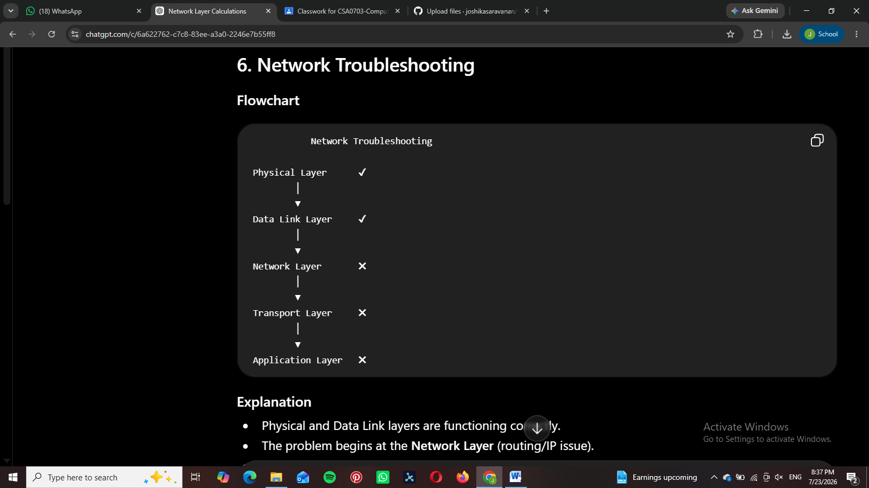
• Physical and Data Link layers are functioning correctly.
• The problem begins at the Network Layer (routing/IP issue).
• Since higher layers depend on lower layers, Transport and Application also fail.
• The concept map helps identify that troubleshooting should begin at the Network Layer.

